The EMERGE Lab
Relevant Logos
EMERGE  Wire Seahorse Black | 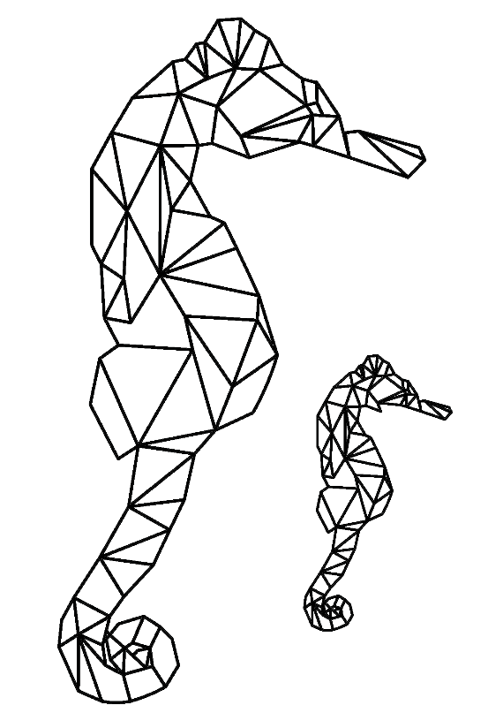
EMERGE
Wire Seahorse
White
University of Southern California Logo
USC
Logo
White
USC
Logo
Yellow

